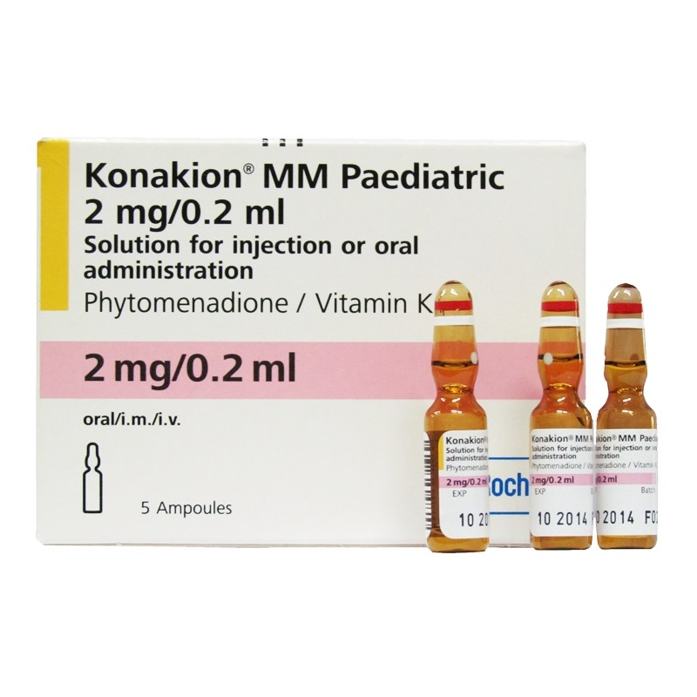  Frenotomy and Vitamin K | Abstract  Bleeding is one of the risks when performing a frenotomy (Tongue tie division). Vitamin K is a substance which supports blood clotting. At birth parents are offered the choice to give their baby Vitamin K, this can be as a single injection into the baby’s leg, a course of oral drops or not to give it at all. This document is to help parents who chose not to give this to their baby, understand the possible risks regarding division.  leonie@mothers-journey.co.uk

Table of Contents
Frenotomy (division of a restrictive lingual frenulum or “tongue tie”) when parents have chosen not to give their baby vitamin K 2
What is the risk? 2
What is the risk of vitamin K deficiency bleeding(VKDB)? 2
Signs and symptoms of VKDB 2
Can a baby still be offered a vitamin K injection (Intramuscular) or oral vitamin K? 3
How many doses and after how many days, can a frenotomy be performed (in the absence of other familial inherited clotting disorders)? 3
Why has the advice changed recently about a clotting screen not being necessary now? 3
What if a baby bleeds more than expected when the procedure is done? 3
Further resources to help aid decision making. 3

Frenotomy (division of a restrictive lingual frenulum or “tongue tie”) when parents have chosen not to give their baby vitamin K

What is the risk?
There is a rare condition affecting infants called Vitamin K Deficiency bleeding (VKDB). It can cause significant bleeding and, in rare cases, death due to intraventricular haemorrhage (bleeding in the brain). It is preventable by either giving a vitamin K injection at birth or a few oral doses of vitamin K in the first month after birth. VKDB usually occurs in the first few months of life and has a peak incidence between 3 and 8 weeks after birth. Essentially there is no real risk of VKBD occurring after the age of 6 months.

What is the risk of vitamin K deficiency bleeding (VKDB)?
The risk of VKDB in the period between birth and age 6 months is highest for babies who are exclusively breastfed. Breast milk has a naturally low content of vitamin K, in contrast to formula milk which contains added vitamin K.
The risk of late onset of VKDB (1 week to 6 months) is estimated to be in the region of 1 in 14,000 for babies who don’t get vitamin K at birth and who are exclusively breastfed.
If a baby is on part breastmilk and part formula milk, then unless they were jaundiced or had delayed or poor feeding, they would probably be getting sufficient ongoing dietary vitamin K intake to avoid VKDB, even if they had not received vitamin K at birth.

Signs and symptoms of VKDB
Unfortunately, in most cases of VKDB, there are NO WARNING SIGNS before a life-threatening event starts.
Babies with VKDB might develop any of the following signs:
- Bruises, especially around the baby’s head and face.
- Bleeding from the nose or umbilical cord.
- Skin colour that is paler than before. For babies with a darker complexion, the gums may appear pale.
- The white parts of your baby’s eyes look yellow after the first 3 weeks of life.
- Stool that has blood in it, is black or dark and sticky (also called "tarry"), or vomiting blood.
- Irritability, seizures, excessive sleepiness, or a lot of vomiting (possible signs of bleeding in the brain).

Can a baby still be offered a vitamin K injection (Intramuscular) or oral vitamin K?
Yes, a baby can still receive vitamin K if the parents choose to do this. It would need to be prescribed and administered by your GP.
Oral or injected vitamin K is a dietary supplement- it is derived from plants and is naturally occurring and has no known toxic effects in humans. Vitamin K is used for full functioning of the blood clotting system in the body.

How many doses and after how many days, can a frenotomy be performed (in the absence of other familial inherited clotting disorders)?
For babies whose parent/s don’t want vitamin K given as an intramuscular injection at birth, should be offered the alternative of three oral doses instead: one at birth, the second after a week, and the third after 4 weeks from birth.
In respect of doing the frenotomy, if a parent would like their baby to have vitamin K prior to division then a single oral dose of vitamin K given at least 1 day before (or first thing in the morning if it is an afternoon procedure) is an option. There is no need to do any routine blood test to check clotting (coagulation screen) before the frenotomy.

Why has the advice changed recently about a clotting screen not being necessary now?
That is because coagulation (clotting) screen is not a sensitive marker for vitamin K deficiency. By the time the coagulation screen becomes deranged (abnormal), a baby would be in advanced deficiency.

What if a baby bleeds more than expected when the procedure is done?
If there is anything more than the usual, small amount of bleeding after frenotomy - such as prolonged oozing, that does not settle within the expected timeframe, e.g., not showing haemostasis (stopping bleeding) within 5-10 minutes, then a baby could possibly be showing minor VKDB and should be considered for further investigation. The baby would not have any life-threatening bleed from the frenotomy site, only prolonged oozing. If VKBD was missed (an intraventricular haemorrhage) if baby had not had vitamin K then this might cause life-threatening bleeding later.

Further resources to help aid decision making.
Vitamin K and the newborn Dr Sara Wickham sarawickham.com
Vitamin K and your newborn Aims.org.uk

I have read and understood this information and wish to continue with division:
Date:
Signature:

