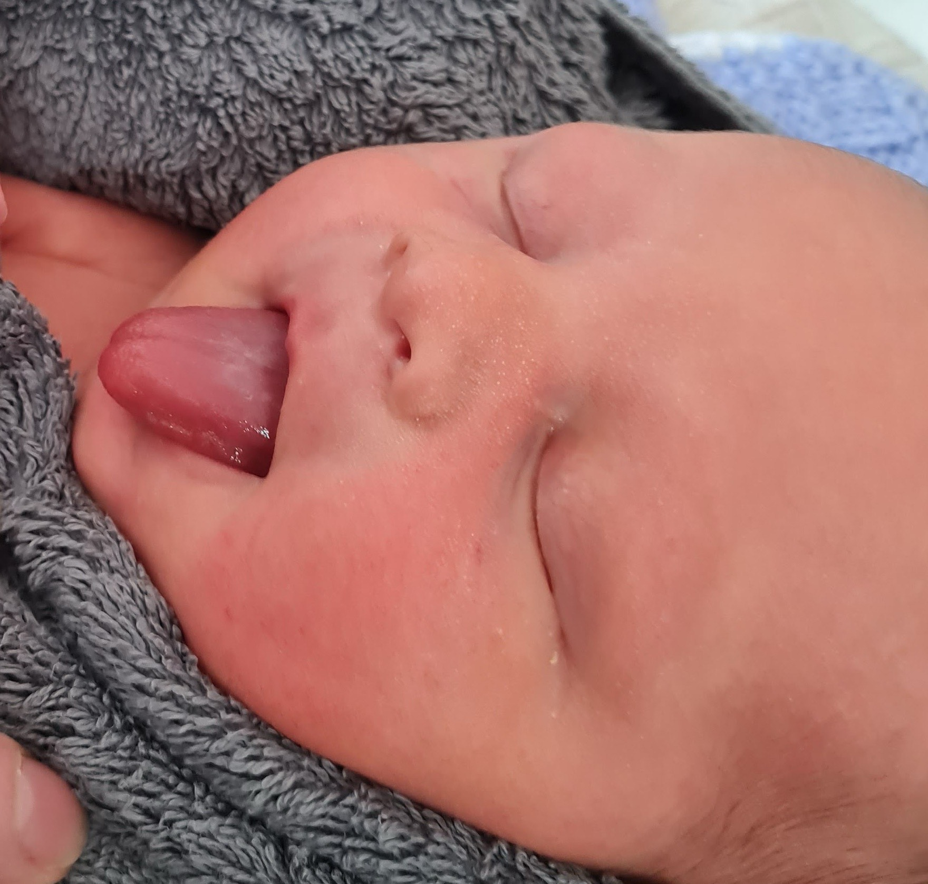  Tongue tie division information  (please read this prior to your appointment) | Abstract  Tongue Tie and frenotomy (Division) can feel quite a worrying and stressful thing to be considering. Most parents would rather avoid having this done to their baby. To help you understand more what is involved and to help inform your decision making, here is some information about the more common questions asked.  leonie@mothers-journey.co.uk

Table of Contents
Tongue tie division information 0
Tongue tie procedure 2
The assessment. 2
If division is indicated 2
Pain 2
Bleeding 3
Bleeding in the hours or days after the tongue tie division 3
Infection 3
Tongue fatigue or tiredness 4
Prior to the appointment 4
Check List before appointment: 4
Home visits only: 5

Tongue tie procedure

The assessment.
I will do as much of the assessment as I can with your baby in a good mood, this may be while they are in your arms, resting next to you on the sofa or I may hold them too. If this provided to be challenging or your baby has other ideas, I may wrap your baby in a thin blanket to be able to examine their mouth fully.
During the examination I will assess your baby’s palate, tongue function and mobility/ movement. I will feel around your baby’s full oral structure, then assess the appearance tongue tie by lifting up the tongue with my finger – this can make babies gag a little, or can feel a little uncomfortable for them, particularly if it is very tight, so I tend to leave this until last as babies tend to shout at me for this. There are various ways to grade or classify a tongue tie, I will explain what method I use beforehand so you will be aware of exactly what I am assessing and what it means and talk through the findings after the assessment so you are able to make an informed decision as to what’s best for you and your baby.
If tongue movements are normal, division is not necessary, however, additional feeding support and treatment by a specialist chiropractor, osteopath or craniosacral therapist, may be advised.

If division is indicated
For the release I will require assistance to hold your baby’s head – either you can do this yourself, or if you feel unable to do this, please can you to have another person present who can. They don’t need to watch what I am doing. Most babies are perfectly happy to suck a gloved finger and therefore are not distressed by the experience.
The tongue tie is divided with sterile, curved scissors to the base of the mouth. A small gauze swab is placed over the wound and pressure applied with a fingertip to stop any bleeding. Your baby is then given straight back to you for a cuddle and a feed.
The entire procedure usually takes a few minutes to perform and you can choose to watch or sit to the side.

Pain
For most parents, pain is their first concern when thinking about whether their baby should have a tongue tie division. Research at Southampton Hospital (involving 10,000 babies) concluded that it is similar to having an injection – briefly painful but no on-going pain. Most babies under 2 weeks will cry for a very short amount of time (if at all).
It is unusual for a baby under 8 weeks to cry for more than 1 minute, whilst older babies may cry for up to 5 minutes (although this is still not common). Babies are normally settled by cuddles and offering a feed straight after the tongue tie division – sucking produces natural painkillers called endorphins and so babies are generally upset for a very short time.
Some babies will become unhappy/unsettled for the first 24-48 hours following a tongue tie division- the tongue and wound site may feel a little achy.
If your baby appears to be in pain, it is safe to give babies over 8 weeks old, liquid paracetamol (calpol) as directed on the packet. Babies under 8 weeks old are only able to have liquid paracetamol under the direction of a GP. If you feel that your baby is in pain, you should telephone your GP practice or out of hours service and you will be given advice as to exactly how much Calpol your baby can be given based on a calculation of your baby’s weight and age.
Anaesthetic is not used for the procedure as most babies are able to tolerate the procedure very well. Using an anaesthetic has not been shown to be beneficial and can cause more distress to your baby. Your baby will also need to be able use the tongue to feed effectively after the procedure, which would not be possible if an anaesthetic is used.

Bleeding
Most babies will only bleed a very small amount (a couple of drops is normal) and this is usually absorbed by the gauze swab placed on the wound in the baby’s mouth immediately following the tongue tie division. Most bleeding stops with direct pressure. The best way to apply this under the tongue is for your baby to feed/suck.
On occasion after your baby finishes their feed the site continues to bleed/ooze. If this occurs, I would encourage your baby to either feed at the other breast, or if bottle feeding offer some more food. If this doesn’t work, then I would cuddle your baby and encourage them to actively and calmly suck on a gloved finger for 10 minutes. If there was still some active oozing or bleeding, then I would apply firm pressure to the wound with gauze and frozen saline for 10 timed minutes and would then recheck the wound site. If this did not stem the bleeding, I would apply a specialist dressing and consider transferring to the nearest hospital. If the bleeding had not resolved, then we would call an ambulance to facilitate a transfer to the nearest hospital. I would continue to apply pressure directly to the wound during transfer to hospital.
The risk of bleeding to this extent, where transfer to hospital would be recommended, is rare (approx. 1 in 3000-5000). Once in hospital, the bleeding is likely to be dealt with by putting pressure on the wound, all the time there is pressure, the baby is not bleeding and therefore not at risk. It is very, very rare for any further treatment to be required.

Bleeding in the hours or days after the tongue tie division
There have been a few reported cases of a baby bleeding a few hours or even days after the original tongue tie division. It can very occasionally be triggered by strenuous crying (resulting in the tongue lifting and disturbing the wound) or when the wound is disturbed during feeding, particularly if the wound is caught by a bottle teat or tip of a nipple shield. This bleeding is usually light and resolves by feeding the baby or giving a dummy or clean finger to suck on (this puts pressure on the base of the tongue and stops the bleeding). If this does not reduce the bleeding, then putting pressure on the wound for 10 minutes in the same way as following the original tongue tie division will stop the bleeding. You may use either some clean gauze or a clean muslin. If you feel the bleeding is heavy and has not stopped, then you need to take your baby to your nearest A&E department. Please be aware that this is very, very rare.

Infection
Infection rates in tongue tie division are extremely low – approximately 1 in 10,000 (from the Southampton study). This is because the mouth heals very quickly and constantly replaces cells. Breast milk is also very protective for babies as it contains antibodies. You may notice a white, pink or yellow diamond shape under your baby’s tongue about 24 hours after the division – this is normal.
It is important that any nipple shields, teats bottles or dummies are thoroughly washed in hot soapy water, rinsed and then sterilised. Fingers should NOT be put in baby’s mouth to suck- unless it is a clean finger and you are performing the gentle exercises as advised. Taking precautions will minimise the risk of infection, so hand hygiene is very important prior to feeding your baby, after nappy changes and prior to doing the exercises. Soap and water is preferable to hand gel, washing hands for at least 20 seconds with soap, rinse and dry well. Signs of infection include swelling or inflammation, redness or pus from the wound. If you are concerned about infection, then we advise that you either contact us or your GP for assessment. Infection is normally treated with a 5-day course of amoxicillin.

Tongue fatigue or tiredness
Once your baby has had a tongue tie division, the tongue begins to move in a new and different way. The tongue is a muscle but due to the tongue tie, it will not have been working effectively and therefore after the division your baby can suffer from tongue fatigue or aching due to the new movement. This explains why some babies will feed very well following a tongue tie division, but then struggle with feeding over the next 24 hours. Like all muscles, the tongue needs to build up strength and this takes time. Tongue fatigue is more noticeable in babies over 2 weeks old and some babies may be quite fussy or refuse to feed for some hours following the procedure. This usually resolves within 24 hours-48 hours, although babies older than 8 weeks may take longer to improve. Offering the breast or bottle, skin to skin, cuddling, rocking and general soothing techniques will help your baby during this time. Babies will often breastfeed if you have a bath with them. Please seek advice either from the tongue tie practitioner or your GP if you are concerned.

Prior to the appointment
Ideally, your baby will have had Vitamin K either by injection or at least 1 oral dose. If your baby has not received Vitamin K, you MUST inform me prior to the appointment. If you have decided against giving your baby to have Vitamin K, a full discussion about the risks of bleeding will be had and information will be shared before the appointment so you are able to make an informed decision.
If you decide that you wish your baby to have vitamin K, this can be organised by your GP.
It is also important that you inform me if there is a family history of bleeding or a clotting disorder, as your baby may need a blood test in the first instance and the procedure may not be able to be performed in a community setting.
If your baby has been diagnosed with an infection or oral thrush, please me as the appointment may need to be delayed for treatment to be completed.
Similarly, if your baby is on any medication or has been diagnosed with a medical condition, please inform me before the appointment.

Check List before appointment:
- If bottle feeding with expressed breast milk or formula, please have a feed ready to use for after the procedure
- Nipple shields if you are using them
- Your child's health record (red book) - (UK only)
- A suitable large muslin, sheet or thin blanket to swaddle your baby
- Please ensure there is someone who is happy to support your baby’s head in case you are unable to do so

Home visits only:
- A surface suitable to put a changing mat on for your baby to have the procedure performed (Kitchen or Dining Room Table is preferable)
- If you have other children, please ensure you have someone who can look after them during the appointment.
PLEASE INFORM ME IF YOU HAVE ANY PROBLEMS WITH ANY OF THESE ITEMS.

