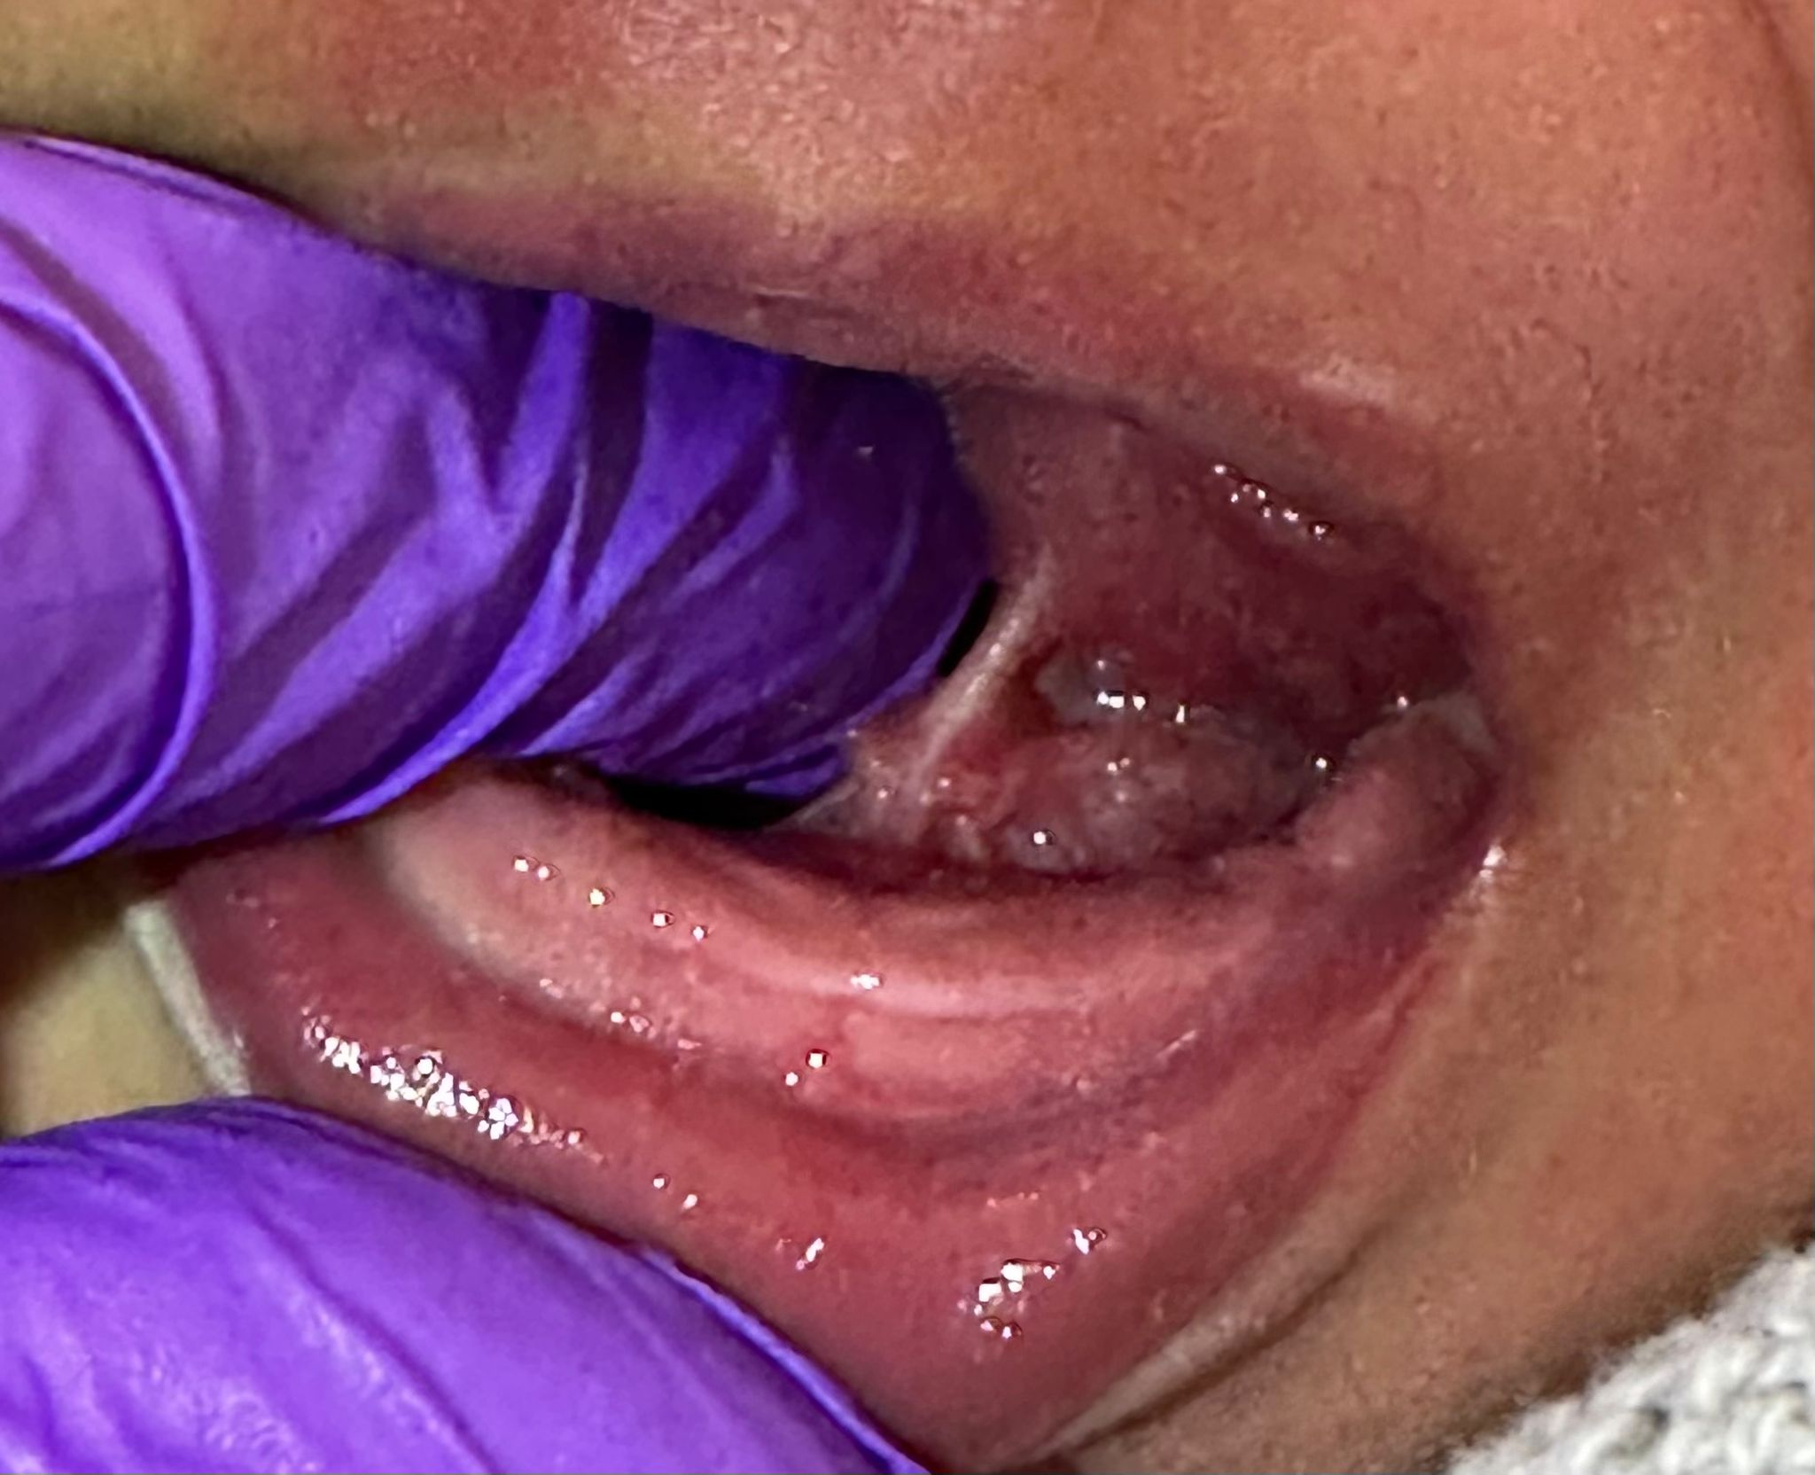  Tongue-Tie Parent Information | Abstract  Tongue tie can be a mine field to navigate, and many midwives, Health visitors and Doctors have very limited knowledge, training or experience in this area. No wonder parents are left feeling confused. Here is some information to give you a taste of what tongue tie is about and what the common signs are for this and if you think this applies to you seek advice from a trained practitioner  leonie@mothers-journey.co.uk

Table of Contents
Tongue-Tie Parent Information Leaflet 0
What is a tongue-tie 1
How may tongue-tie affect your baby? 1
Breast fed babies 1
For Parents, there may be: 1
If your baby is bottle feeding, they may: 2
Lip Tie (Labial Frenulum) 2
Further information on Tongue-Tie 2

What is a tongue-tie
The medical term for tongue-tie is Ankyloglossia, where the piece of skin on the underside of the tongue (lingual frenulum) and the floor of the mouth is tight or restricts the movement and mobility of the tongue. Here are some examples below, but there are many variations.
During the baby’s development in the uterus, this piece of skin or membrane is there to aid the formation of the mouth. Towards the end of the woman’s pregnancy, the membrane usually thins and by birth, the membrane is attached loosely to the base of the mouth and tongue. All humans have a frenulum, it is an important structure that stabilises the tongue to the floor of the mouth.

How may tongue-tie affect your baby?
The presence of a lingual frenulum may not affect your baby at all; however, some babies do have difficulty with breast feeding or they may adapt quickly to a way of feeding that is effective for them but can cause trauma to nipples or other issues. Babies who are bottle feeding may also have problems and struggle with effective feeding.

Breast fed babies
In order to breastfeed successfully, babies need to attach to the breast correctly by taking the nipple to the back of the mouth and having a good amount of breast tissue in the mouth.
The tongue needs to come forward to cover the lower gum, spread around the breast, lift up and cup the breast, and then hold this while the body of the tongue undulates in a peristalsis way.
Babies with tongue-tie often struggle to open their mouth wide enough to take in the breast; they may try to ‘hang’ on with their lips, or they use their gums to bite and hold. This can cause damage to the nipples and pain for the parent. Babies often feed ineffectively; take a long time to feed and get tired. By not draining the breast this may lead to engorgement, or cause mastitis or an oversupply of milk, in addition the baby may need to feed little and often.
If your baby has a tongue-tie, there may be some of the following issues:
- Difficulty with attaching to the breast correctly
- Difficulties staying attached or having to be removed constantly due to incorrect and ineffective attachment.
- Feeding for less than 5 minutes or over an hour at every feed.
- Feeding more than 12 times in 24 hours, taking small amounts only
- Fall asleep or become disinterested during feeds.
- Be fussy, head banging, fists clenched when preparing for a feed.
- Be unsettled in between feeds.
- Lose more weight than expected in the first week of birth or slow to regain birth weight and poor weight gain thereafter.
- Suffer with excessive wind.
- Reflux (vomiting after feeds-more than the normal possit).
- Be noisy feeders when they lose suction or you may hear a constant click throughout the feed.

For Parents, there may be:
- Sore damaged nipples.
- Exhausted from frequent feeding.
- Misshapen nipples after feeding.
- Lumpy breasts (from blocked ducts) leading to pain, redness and possibly mastitis (infection in the breast).
- An oversupply of milk with engorgement, which can then lead to a low milk supply as the breasts are not drained sufficiently by efficient feeding.
- Breasts that still feels very full even after feeding.

If your baby is bottle feeding, they may:
- Find it difficult to bottle feed.
- Take a long time to feed > 1 hour.
- Drink only small frequent feeds.
- Dribble a lot of milk from the sides of the mouth.
- Take in excessive air.
- They may not be able to keep a dummy in the mouth (if you are using one).

Lip Tie (Labial Frenulum)
Lip ties are normal anatomy, everyone including adults has one; currently there is no published evidence to show that it interferes with feeding. It usually recedes as your baby grows and as the top teeth erupt. However, for some children, a tight lip tie can affect tooth alignment causing a gap between the top teeth. Most people do not require any intervention unless they decide they do not want a gap or the orthodontist advises that it is necessary for dental problems. In this case it is usually corrected (if necessary) during the teenage years by the dentist/oral surgeon or orthodontist.

Further information on Tongue-Tie
You can find out more information from the following web sites
- NICE Guideline available at www.nice.org.uk
- Association of Tongue-Tie Practitioners www.tonguetie.org.uk
- UNICEF http://www.unicef.org.uk/BabyFriendly/ (search for tongue-tie)
- La Leche League GB
- Breastfeeding Network
- Association of Breastfeeding Mothers

