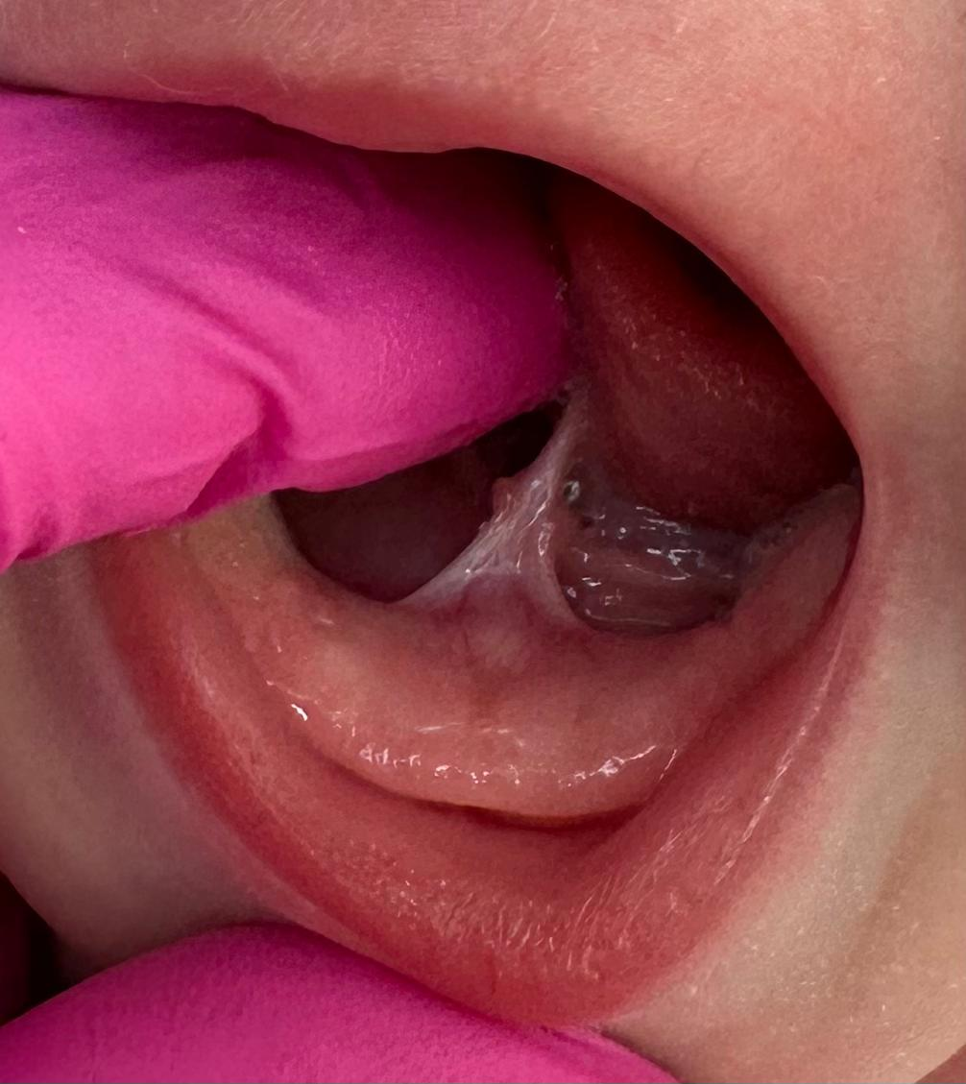  Aftercare Following Tongue-Tie Division | Abstract  Making the decision to have your babies tongue tie released can be daunting. This information resource will hopefully answer any questions you might have.  leonie@mothers-journey.co.uk

Table of Contents
Aftercare Following Tongue-Tie Division 0
How will my baby be after the procedure? 2
What does the wound look like? 2
Infection 2
Further Bleeding Following the Procedure 2
Post tongue-tie exercises 3
Tongue poking 3
Lateralization of the tongue 3
Tongue massage 3
De-sensitizing the palate 3
Lifting the tongue 4
Active (or disruptive) wound management 4
Is there risk of reformation (reattachment)? 4
Follow up after tongue-tie division 5
Resources 5

How will my baby be after the procedure?
Most parents report that there is little difference in the way the baby reacts after the procedure. A small number of babies over 6 weeks old may be unsettled and cry, sometimes they may refuse to feed; having skin to skin in the bath, cup or finger feeding, can help if babies are reluctant to latch.
During the first 24 hours after the procedure, your baby may feed more than usual, as your baby may want to be comforted, this is normal, both sucking and the natural sugar in the milk helps with pain relief.
Babies over 8 weeks old, often require Infant Paracetamol Suspension. If your baby is UNDER 8 weeks old, please speak to your GP as pain relief will need to be prescribed. If you have any concerns speak to your tongue-tie practitioner.

What does the wound look like?
Healing commences very quickly. Within the first few days, you will notice a yellowy/white patch (normally diamond or triangular shape) under the tongue at the wound site; this is a normal part of the healing process. The colour will change to a whitish/grey colour, usually disappearing within 2 weeks. If your baby is jaundiced, the wound will appear as a bright yellow patch, rather than white, until it is healed or the jaundice subsides.

Infection
Infection is a rare complication of tongue-tie division affecting around 1:10,000 divisions. However, if there is any sign of redness, swelling, discharge (pus), please contact your GP or out of hours service (111). If you are unsure and need advice which is not urgent, please contact your tongue-tie practitioner.

Further Bleeding Following the Procedure
Occasionally, you may notice a small amount of pinky saliva in your baby’s mouth in the first few hours following the procedure, this is normal. Encouraging your baby to suck (breast/bottle, dummy or clean finger) will help to apply pressure to the wound and generally stops any mild bleeding.
It is uncommon for babies to bleed again in the days following the division, however if this does occur, encouraging your baby to suck for at least 5-10 minutes will generally stop any bleeding. If this does not stop the bleeding and it appears heavy, apply some pressure to the wound under the tongue with one finger and a clean muslin/cloth or gauze. Take care not to obstruct the airway and check the wound after 10 minutes of pressure. If the wound is still bleeding keep the pressure on the wound, call 999 for an ambulance if you are a long way from the hospital or alone.
Taking care not to disturb the wound with dummies, teats or excessive crying helps minimise the risk of bleeding.
Your tongue-tie practitioner will talk you through what to do, should an emergency occur after the appointment. Please ask if you have any worries.

Post tongue-tie exercises
Exercises are best done when your baby is in a quiet alert or early active stage so that it can be fun and enjoyed. If your baby is reluctant or in-different then leave it until later.
The following exercises are adapted from C Genna Watson book "Supporting sucking skills in Breastfeeding infants" Chapter 8. Ensure your hands are clean and fingernails are short.

Tongue poking
- Sit your baby in front of you and poke your tongue out! Your baby will copy you even if they are newborn. Sucking exercise (30 secs prior to every feed for the next 48 hours)
- Touch stimulation to chin/nose area between top lip and nose. When baby opens mouth in response put your finger pad into the roof of the mouth (palate) and encourage your baby to suck your finger. Once there is a good suck going, quickly pull your finger out of the mouth to create a ‘pop’ sound. This encourages tongue poking.
- Make silly sounds while doing this and smile at you baby to make it fun!
Lateralization of the tongue (30 secs prior to every feed for the next 48 hours)
- Stimulate you baby to open its mouth by gently tapping on or around their lips, run your fingertip along the gum line from side to side. The tongue can be seen to follow the finger and daily exercise will increase your baby’s ability to protrude its tongue.
Tongue massage (only needed if your baby has excessive saliva)
- Stimulate area above top lip to encourage baby to open its mouth.
- Place finger pad on surface of tongue behind tongue tip
- Rotate finger in small circular movement maintaining contact with tongue. If your baby attempts to suck the finger turn the finger upwards so the finger pad rests on the palate and further massage the tongue.
De-sensitizing the palate (only needed if your baby has a strong gag reflex)
- Some tongue-tied babies (or babies with a high palate) may have a strong 'gag' reflex. this exercise can assist in de-sensitizing the palate. Place your finger back along the hard palate, stopping just before the 'gag' reflex is stimulated. Over several sessions your baby will learn to tolerate the pressure to the palate and this de-sensitizes the reflex making feeding easier. This exercise should be done several times daily, often for several months.

Lifting the tongue (morning/evening for the next 48 hours)
- I encourage you to gently lift the tongue using both of your index fingers to ensure that the wound has not begun to heal closed. This exercise is a little tricky, so we only ask you to do it 4 times in the first 48 hours.
- For older babies: you may also find an “O” ball useful to encourage tongue movements (available from toy shops).
I recommend that the exercises (other than the tongue lift) are performed as often as possible in
the first 48 hours, ideally before every feed and then several times a day for at least 14 days following the division.
If you are breastfeeding, this will be a great way to encourage optimal oral function. Encourage your baby to feed at least every 2.5 – 3 hourly following the division. This encourages good tongue movement.
If your baby has been bottle fed and you are keen to get your baby back onto the breast, you may find that using a nipple shield for a short period of time may help; please ask if you need help with feeding.

Active (or disruptive) wound management
I do not currently recommend active wound management – this is aggravation of the wound which was thought to prevent possible reattachment, as there is currently no published evidence to show that it reduces the risk of reattachment. Currently, there is little evidence that exercises of the tongue by stretching it with the fingers and breaking the wound open (Disruptive Wound Management) actually reduces reformation. It will disturb the healing tissue and could cause bleeding or infection. And there are concerns about oral aversion/pain experienced by babies, stress and anxiety caused for parents.

Is there risk of reformation (reattachment)?
There is a small risk (about 2-4%) that the frenulum will reform and cause restricted tongue mobility. You may notice that the symptoms begin to worsen when they had been improving. This can be really common in the first few weeks following division, This will be due to the nature of a healing would which ca become tighter as it heals, and equally likely to be due to tongue fatigue as your baby is learning to work the tongue muscle more efficiently and in a new way. This usually improves with exercises, feeding and time. If this persists please contact me for advice.
A further assessment can be performed and another division of the frenulum offered, if necessary, but generally not before 4-6 weeks of healing from the original division. Due to scarring, it is discouraged to divide the frenulum more than twice as this itself can cause restriction of tongue movements and function.
The frenulum is an important structure and will always reform, so if you see a frenulum, it does not mean that there is a problem. If feeding is going well and the frenulum allows good mobility of the tongue with good function, it will not require re-division.
If your baby has had the division performed elsewhere, if possible, it is important to return to the professional who performed the first procedure, most practitioners will be open and supportive and will want you to have the best experience possible. If you decide you still wish to see another me I will need to perform a full holistic assessment of your baby’s oral and sucking function, a feeding assessment and would charge the full amount for the appointment and procedure.
It is important to note that research shows division of the tongue-tie does significantly improve infants feeding, however this is not in all cases.
Some babies with a high palate, may still have a particularly shallow gape/latch and need further feeding assistance/advice.
Babies who have had difficult labours or births (Caesarean Section, Ventouse, Forceps births, long or very quick labours) may benefit from seeing a cranial osteopath, cranio-sacral therapist or chiropractor prior to or following the tongue tie procedure. This can help restore the natural balance in the body and relieve any tension in the muscles/ ligaments and tissues that can also affect feeding.

Follow up after tongue-tie division
It is my normal practice to contact you the next day to enquire about your baby’s ongoing feeding. If you are concerned at any point over the coming days or weeks, please contact me for advice by text/telephone or email.
I always recommend follow up access for breastfeeding support from a local feeding group or Lactation Consultant (IBCLC) or feeding specialist in the days/weeks following the tongue tie division. You can also book me for 1-2-1 feeding support.

Resources
Tongue tie oral motor and body exercises for young baby
https://youtu.be/3ZQ2-A9K6MI?si=O0YX_x2EQ8vp5t68
Suck training exercises:
https://www.youtube.com/watch?v=ABSUpcmWpZ0
https://www.youtube.com/watch?si=mXFtblu6jQCtZ2AA&v=asXyHA18HsM&feature=youtu.be
Suck training exercises for the older baby:
https://youtu.be/CoN3I-5NDrE?si=iNAaTKPto32udFam
https://www.youtube.com/watch?v=VmKWAr9RCEg
Tongue Lift:
https://m.youtube.com/watch?v=kJY_jme2sOA&pp=ygUZU2xlZXAgc3RyZXRjaCB0b25ndWUgdGllIA%3D%3D

